City of Bastrop Permit Requirements

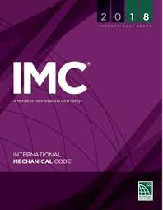

International Mechanical Code (IMC)
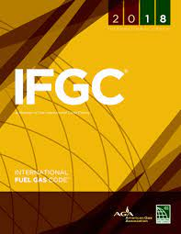

International Fuel Gas Code (IFGC)

106.1 Where required.
An owner, owner’s authorized agent or contractor who desires to erect, install, enlarge, alter, repair, remove, convert or replace a mechanical system, the installation of which is regulated by this code, or to cause such work to be performed, shall first make application to the code official and obtain the required permit for the work. (IFGC)

Exception: Where appliance and equipment replacements and repairs are required to be performed in an emergency situation, the permit application shall be submitted within the next working business day of the Department of Inspection. (IFGC)

106.2 Permits not required.
Permits shall not be required for the following:
- Portable heating appliances. (IFGC, IBC, IRC)
  - (IRC – adds cooking and clothes drying appliances)
- Portable ventilation appliances and equipment. (IBC, IRC)
- Portable cooling units. (IBC, IRC)
- Steam, hot water or chilled water piping within any heating or cooling equipment or appliances regulated by this code. (IBC, IRC)
- The replacement of any minor part that does not alter the approval of equipment or an appliance or make such equipment or appliance unsafe. (IFGC, IBC, IRC)
- Portable evaporative coolers. (IBC, IRC)
- Self-contained refrigeration systems that contain 10 pounds (4.5 kg) or less of refrigerant, or that are actuated by motors of 1 horsepower (0.75 kW) or less. (IBC, IRC)
- Portable fuel cell appliances that are not connected to a fixed piping system and are not interconnected to a power grid. (IRC)

